# Assignment 4

1. Create a list of String and print the values in reverse order

Input – Java, Selenium, TestNG, Git, Github

Output- Github, Git, TestNG, Selenium, Java

Program:

**package** assignement4;

**import** java.util.ArrayList;

**import** java.util.Collections;

**import** java.util.List;

**public** **class** Task1 {

**public** **static** **void** main(String[] args) {

List<String> l1=**new** ArrayList<String>();

//Java, Selenium, TestNG, Git, Github

l1.add("Java");

l1.add("Selenium");

l1.add("TestNG");

l1.add("Git");

l1.add("Github");

System.***out***.println("Original list:"+l1);

Collections.*reverse*(l1);

System.***out***.println("Reverse of List:"+l1);

}

}

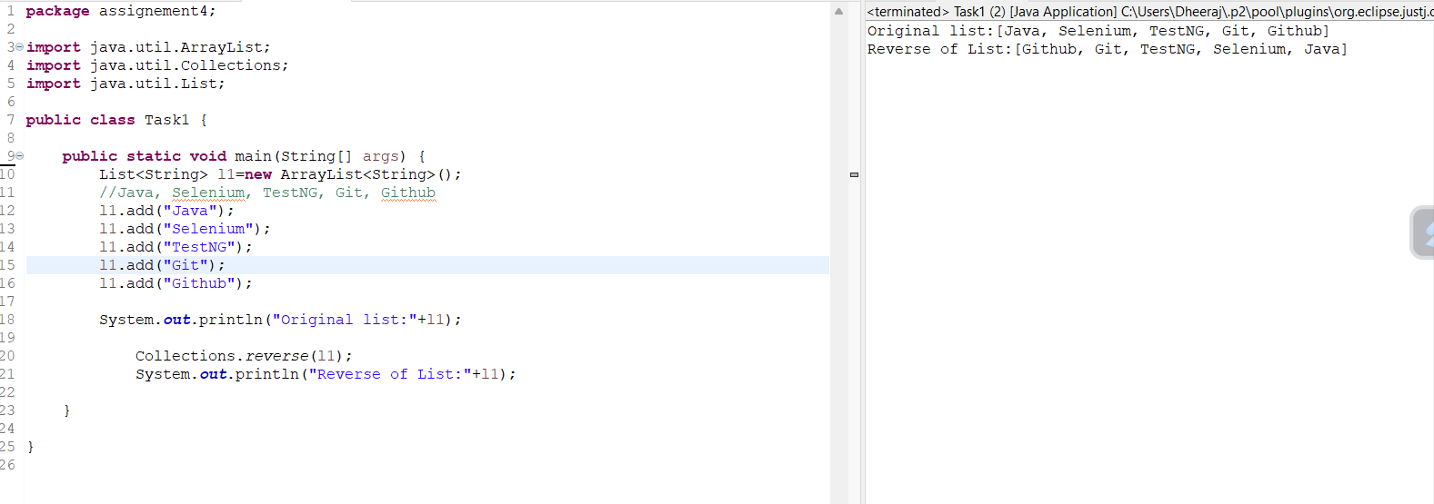

1. Write a program which will accept List of String and produce another List of string of which will have only values which starts with git

Input – Git, Github, GitLab,GitBash, Selenium, Java, Maven

Output- Git, Github, Gitlab, GitBash

Program:

package assignement4;

import java.util.ArrayList;

import java.util.List;

public class Task2 {

private static String[] strings;

public static void main(String[] args) {

// Git, Github, GitLab,GitBash, Selenium, Java, Maven

List<String> l1=new ArrayList<String>();

l1.add("Git");

l1.add("Github");

l1.add("GitLab");

l1.add("GitBash");

l1.add("Selenium");

l1.add("Java");

l1.add("Maven");

//print the input list as a comma-separated string without the enclosing square brackets

String output = String.join(", ", l1);

System.out.println("input-"+output);

//List of string of which will have only values which starts with git

String keyword="Git";

System.out.print("Output-");

for (String item : l1) {

if (item.contains(keyword)) {

// System.out.print(keyword + " Output :" + item);

System.out.print(item + ", ");

}

}

}

}

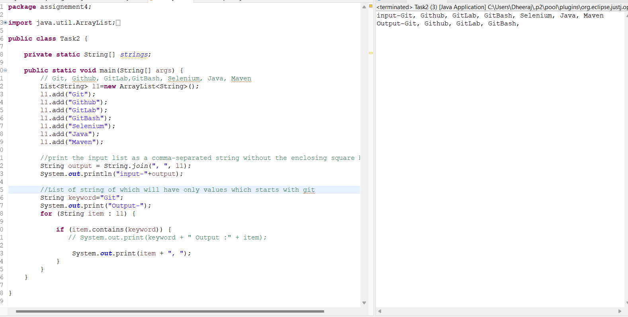

1. Write a program that will remove duplicate values from List

Input – Java, TestNG, Maven, Java,

Output – Java, TestNG, Maven

Program:

**package** assignement4;

**import** java.util.ArrayList;

**import** java.util.HashSet;

**import** java.util.List;

**public** **class** Task4 {

**public** **static** **void** main(String[] args) {

List<String> l1=**new** ArrayList<String>();

//Java, TestNG, Maven, Java,

l1.add("Java");

l1.add("TestNG");

l1.add("Maven");

l1.add("Java");

//print the input list as a comma-separated string without the enclosing square brackets

String output = String.*join*(", ", l1);

System.***out***.println("Input-"+output);

//Convert Arraylist into hashset to remove duplicate element

HashSet<String> hashSet = **new** HashSet<>(l1);

String output1 = String.*join*(", ", hashSet);

System.***out***.println("Output-"+output1);

}

}

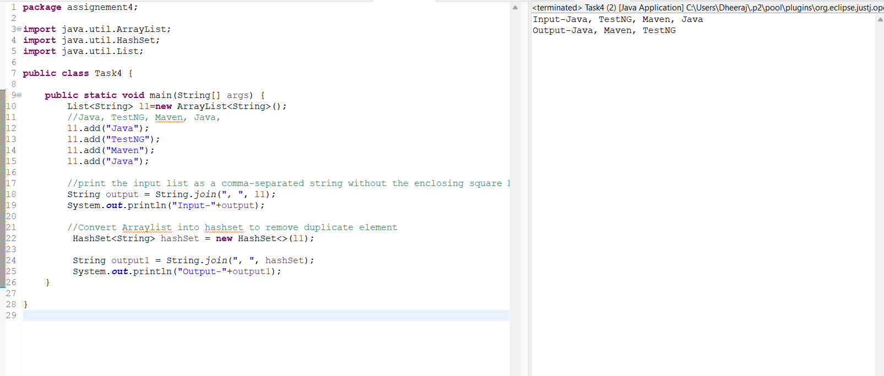

1. Create a list of values and print the second element, second last element.

Input – 10,45, 90,45, 23, 90, 44

Output – 45,90

Program:

**package** assignement4;

**import** java.util.ArrayList;

**public** **class** Task4 {

**public** **static** **void** main(String[] args) {

// Input – 10,45, 90,45, 23, 90, 44

//Output – 45,90

ArrayList<Integer> a1=**new** ArrayList<Integer>();

a1.add(10);

a1.add(45);

a1.add(90);

a1.add(45);

a1.add(23);

a1.add(90);

a1.add(44);

System.***out***.println("Input-"+a1);

System.***out***.println("Output-"+a1.get(1) + ","+ a1.get(a1.size()-2));

}

}

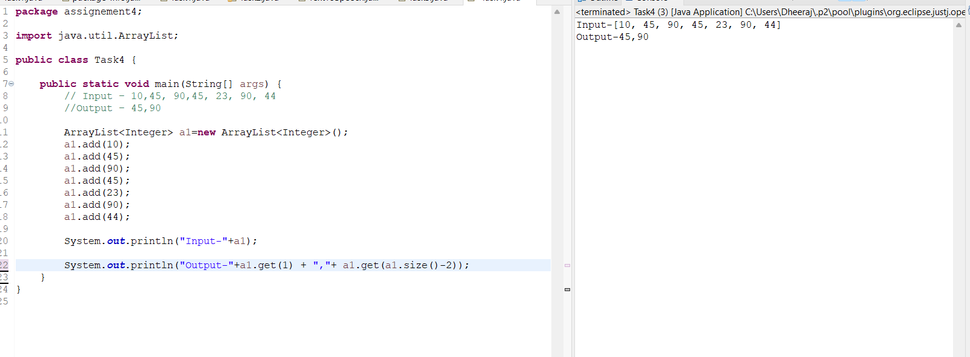

1. Create a list which can accept another list as an element.

List 1- 11,22,33

List 2- 9,19,29

List 3- 7,17,27

Hint - ArrayList<ArrayList<Integer>> l1=new ArrayList<>();

Program:

**package** assignement4;

**import** java.util.ArrayList;

**public** **class** Task5 {

**public** **static** **void** main(String[] args) {

// List 1- 11,22,33

// List 2- 9,19,29

// List 3- 7,17,27

//First List

ArrayList<Integer> a1=**new** ArrayList<Integer>();

a1.add(11);

a1.add(22);

a1.add(33);

System.***out***.println("List 1-"+a1);

//Second List

ArrayList<Integer> a2=**new** ArrayList<Integer>();

a2.add(9);

a2.add(19);

a2.add(29);

System.***out***.println("List 2-"+a2);

//Third List

ArrayList<Integer> a3=**new** ArrayList<Integer>();

a3.add(7);

a3.add(17);

a3.add(27);

System.***out***.println("List 3-"+a3);

//another list as an element

ArrayList<Integer> a4=**new** ArrayList<Integer>();

a4.addAll(a1);

a4.addAll(a2);

a4.addAll(a3);

System.***out***.println("Combined List-"+a4);

}

}

